Year 4 Week Commencing 4th May Maths
Hi everyone,
I hope you had a lovely weekend – were you able to enjoy the nicer weather by getting out for a walk? The weather looks like it will be a bit nicer this week, which will certainly cheer me up.
I’ve made this one document to help you with all your maths this week. We are using the White Rose Maths website, which has lessons for each day up there, with video clips to watch and the activities and answers. You might not be able to download the activities or answers from the website directly any more because they are restricting access, but I can get them, so I will make sure they are emailed out to you each day, and that they’re up on our school website as well, so you can download them from there if that’s easier.
Here is the link to the White Rose website for this week’s learning clips:
https://whiterosemaths.com/homelearning/year-4/
Here is the link to our school website, and the Year 4 page, where you can get the activities and answers (they will still be emailed out to you as well):
https://www.ivingswoodacademy.org/page/?title=Year+4&pid=100
This week is all about multiplying and dividing – something that I know we have learned before, so you should remember how to do most of this. If you have been practising your TT Rockstars as well, then you’ll have an even bigger advantage!
- Monday – multiplying 2-digits by 1-digit
- Tuesday – multiplying 3-digits by 1-digit
- Wednesday – dividing 2-digits by 1-digit
- Thursday – dividing 3-digits by 1-digit
- Friday – take the day off and enjoy VE Day!
To give you a bit of a helping hand, here are the Success Criteria for multiplying in a column and dividing using the bus stop method.

SC Column Multiplication
- Line your calculation up in a column with the larger number on the top, and the single digit number underneath – in the correct place value spot!
- Multiply ones x ones, put your answer underneath, remembering to regroup any tens underneath into the tens column.
- Multiply ones x tens, remember to add any regrouped tens and put your answer underneath remembering to regroup any hundreds into the hundreds column.
- Multiply ones x hundreds, remember to add any regrouped hundreds and put your answer underneath regrouping any thousands into the thousands column if needed.
- Check over your calculations to make sure – see if you can spot any mistakes and fix them yourself, remember that mistakes are the best way to learn!

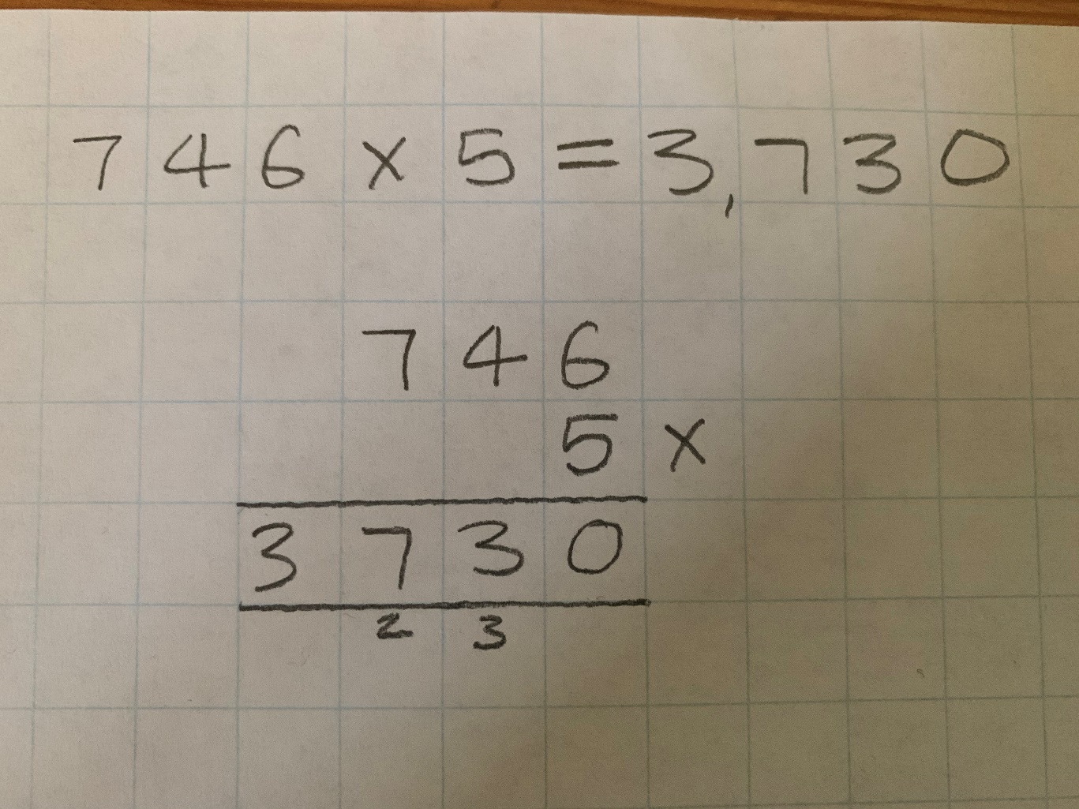

SC Bus Stop Division
- Draw your bus stop, put the number you are dividing (the large number, called the dividend) inside the bus stop and the number you are dividing by (the single-digit smallest number called the divisor) outside. The answer is written above and is called the quotient! Do you remember those names?
- Divide the largest place value first, either your ten or your hundred. Put the answer above the bus stop and regroup any remainders into the next lowest place value.
- Divide the next lowest place value, either the one or the ten. Remember to account for any regrouped digits. Put the answer above the bus stop and regroup any remainders either as a remainder at the end with a small ‘r’, or into the next lowest place value if you have one left.
- Divide the final place value remembering to account for any regrouped digits. Put your answer above the bus stop and regroup any remainders as a remainder at the end shown with a small ‘r’.
- Check over your calculations to make sure – if you’ve made a mistake and spotted it well done, that’s great learning!
- © Can you use the inverse to check your work, do a column multiplication to see if you got it correct?
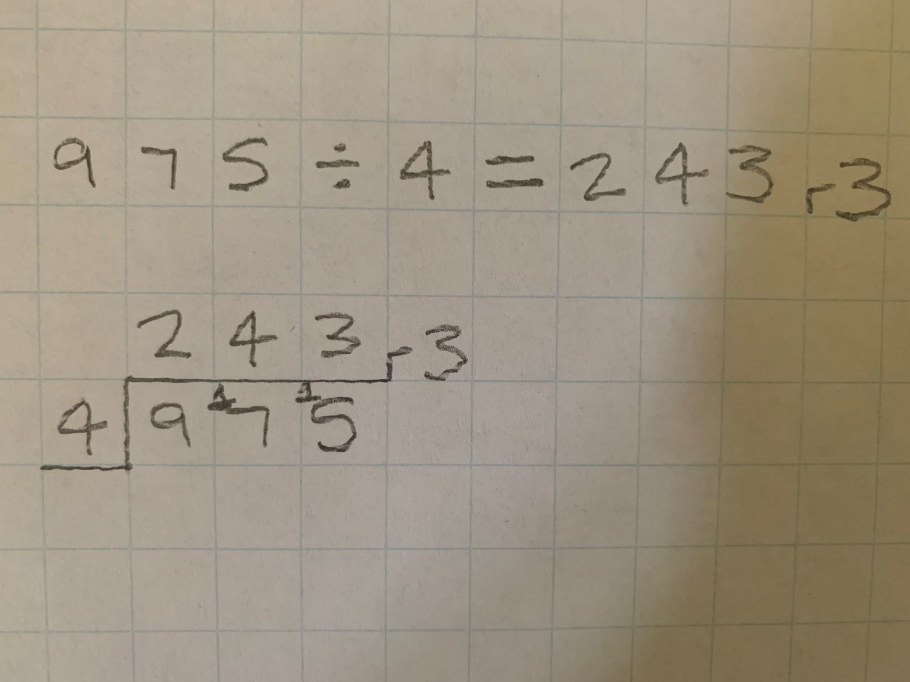
Have a go and try your best, if you get a bit stuck or are confused don’t worry, there is lots you can do. Look at the videos again, read through my success criteria, and look at my examples. I will be calling you all again this week and will be happy to talk you through any problems you might have. If, after all that, you’re still finding it tricky, please don’t worry – you know that I will make sure to go over all this with you when we are eventually back at school, and I’m sure it will be fine then. Good luck!
Miss Smith

