Year 4 Monday 4th May 2020
Hi everyone,
So, today for English please look at Friday’s lesson: Friday 4th May – it’s a reading comprehension on a section of The Worst Witch, by Jill Murphy. The BBC are trying to make their lessons as exciting as possible by having special guests appear in their videos – who knows the special guest from this lesson? If you’re not sure who she is, maybe your parents could give you a clue or have a guess?!
Here is the link:
https://www.bbc.co.uk/bitesize/articles/z7rrcqt
There are two clips to watch of the special guest reading the story, as the BBC asks, try thinking about these questions while you are listening to the first one:

- What is Mildred like?
- Would you want to be friends with her?
- What does 'hair-raising' mean?

Then these questions while you listen to the second clip:
- What do you think about Ethel in this extract?
- Does Ethel deserve what she gets?
- Should Mildred be sorry?

There are then 3 activities for you to do. You don’t have to do all of them, maybe choose just one, or if you really want to challenge yourself, choose two at the most. Happy Reading!

Activity 1: Read the extract yourself, think about how the author uses language to describe the characters and tell you what is happening in the plot. Can you copy out the table and explain what the quotes tell you about the characters or the plot?
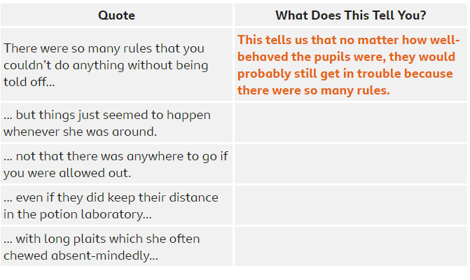

Activity 2: Read the second extract yourself and think about the characters of Mildred and Ethel. The dialogue (what and how the characters speak) gives us clues as to what that character is like. Can you copy out the table and explain what the quotes tell you about the characters of Mildred and Ethel. Are they similar, or different? How so?
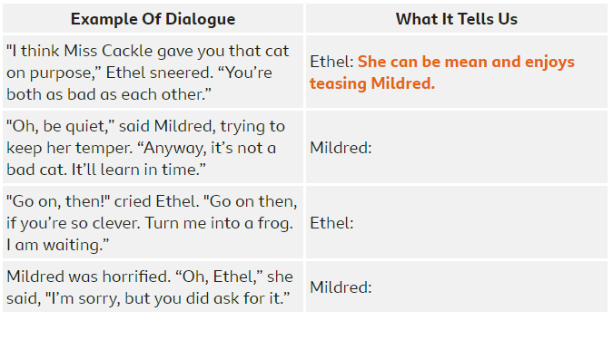

Activity 3: Having read the second extract yourself you’ll know that it ends on an exciting cliff-hanger, can you make 4 predictions about what might happen next? Use the suggested ideas and sentence starters to help you!
- Will Mildred be able to reverse the spell?
- Will a teacher come and discover what Mildred has done?
- Will the 'pig’ run away?
I think …
I wonder if …
I don’t think …

